ITP 104 Project Summary

**Topic:** Personal Website (Kim Do)

**Purpose:** My website is a personal portfolio that will contain content featuring some of my professional experience and projects I've conducted academically and for fun. It's supposed to highlight my best work and display my accomplishments, skills, and potential for future projects that employers might be interested in. This includes a short bio of myself, a list of projects I created, and a contact page in order to get in touch with me.

**Extras Used:** Javascript Plugins, Bootstrap, and Form

* JS Plugin - <https://www.darkcode.info/2020/03/animated-skills-bars-using-html-css.html>
  + Created an animated skills bar that highlights my technical skills
* JS Plugin - <https://speckyboy.com/css-javascript-text-animation-snippets/>
  + Created a typing title “opening” on the home page

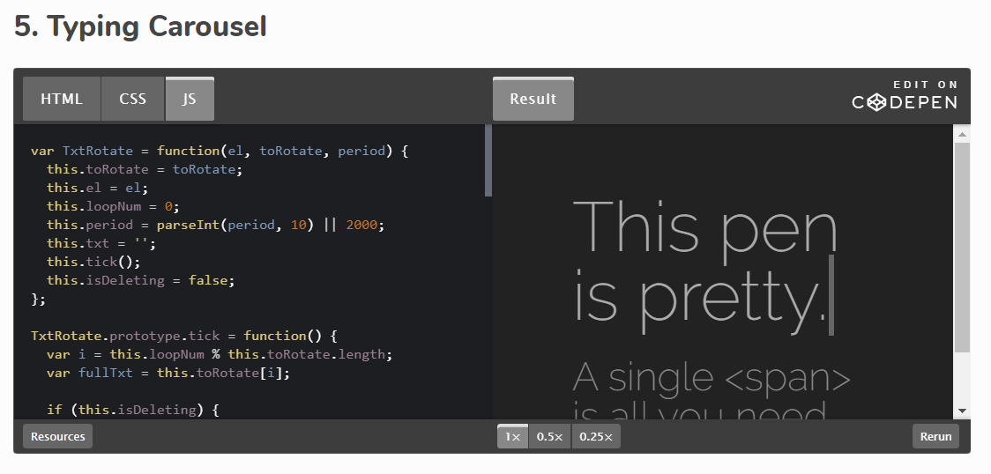

* Bootstrap - <https://www.bootstrapcdn.com/fontawesome/>
  + Created animated social icons on the contact page
* Form/JS Plugin – <https://github.com/codingmarket07/Contact-us-form-validation-Using-Javascript-M8>
  + Created a form contact page with a pop-up validation by using JavaScript